13.96: In each situation, imagine the mass moves a distance 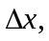 the springs move distances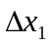 and 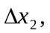 with forces 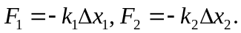 a)
b) Despite the orientation of the springs, and the fact that one will be compressed when the other is extended, 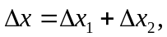 and the above result is still valid; 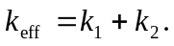
c) For massless springs, the force on the block must be equal to the tension in any point of the spring combination, and 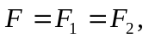 and so 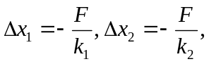 and
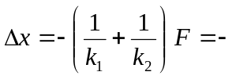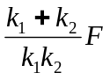
and 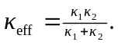 d) The result of part (c) shows that when a spring is cut in half, the effective spring constant doubles, and so the frequency increases by a factor of 